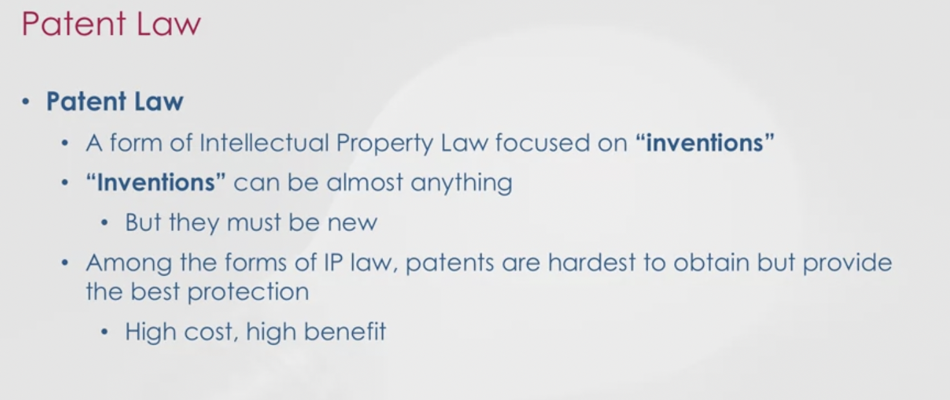

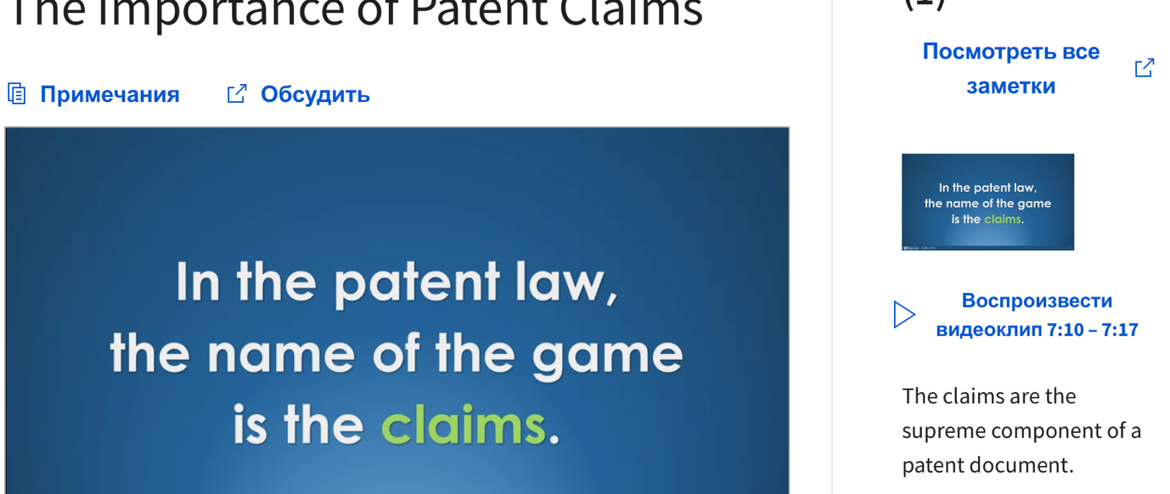

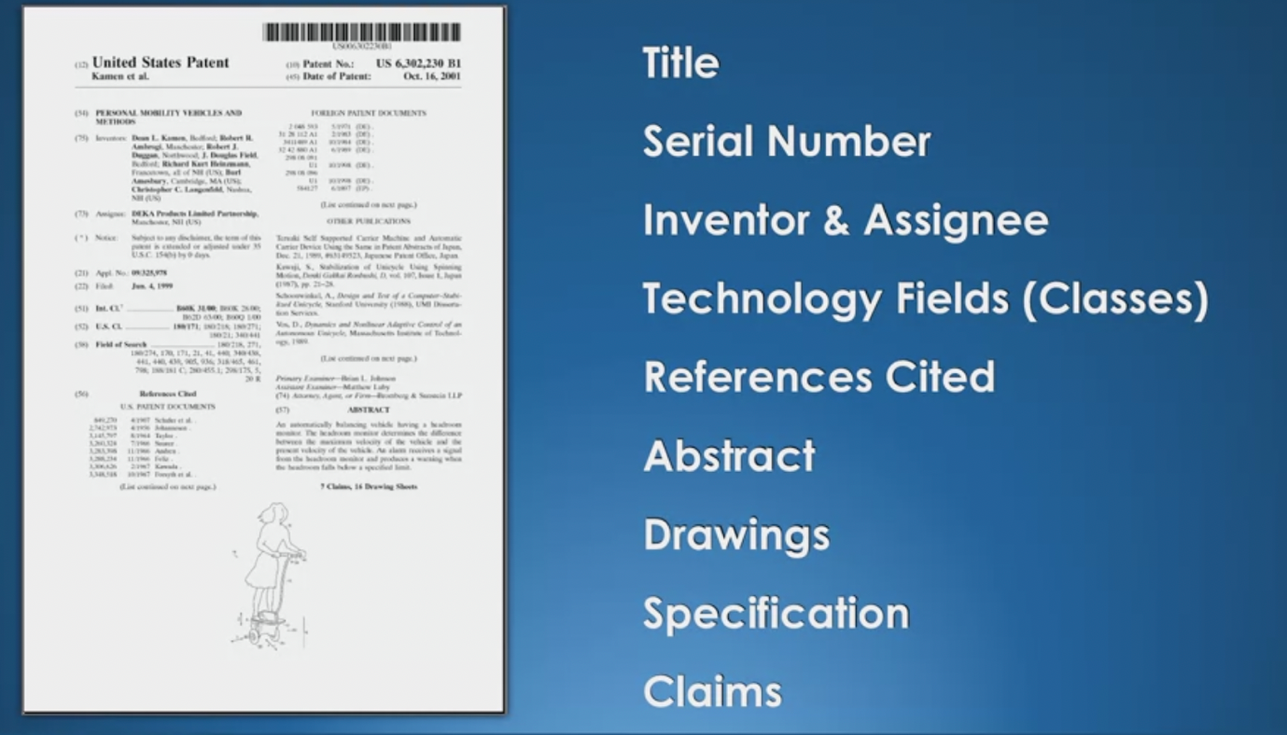

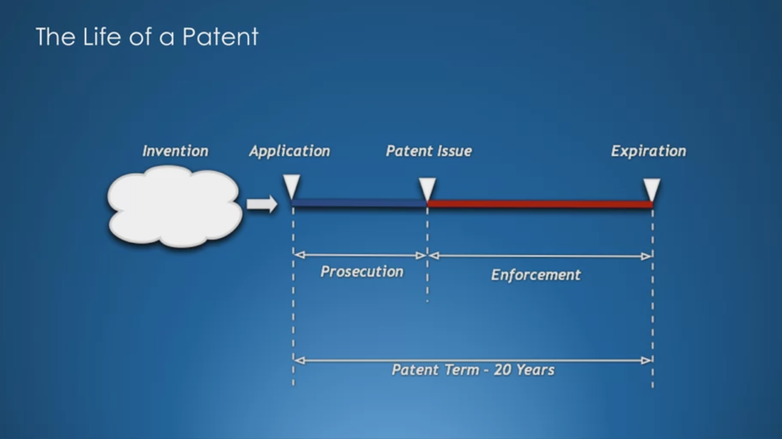

1. An invention shall be granted legal protection if it is new, involves an inventive
step and capable of being industrially applicable.
An invention shall be deemed new if it is not anticipated by prior state of art.
An invention shall involve an inventive step if, having regard to the state of the art,
it is not obvious to a person skilled in the art.
The state of the art shall consist of any kind of information published anywhere in the
world, and made available to the public, before the priority date of the invention.
When the novelty of an invention is being determined, the state of the art shall also
include, upon the condition of their earlier priority, all applications filed in the Republic
of Kazakhstan by other applicants for inventions and utility models (except for the revoked
ones), and inventions and utility models that have been patented in the Republic of Kazakhstan.
An invention shall be deemed industrially applicable if it can be used in industry,
agriculture, public health and other sectors of the economy.
2. Such technical solutions of any field that relate to the product (a device, substance,
microorganism strain, the culture of plant cells or animals), method (the process of affecting
a material object using material resources), as well as the application of known product or
process for a new purpose, or the use of a new product for a particular purpose shall be
protected as an invention.
3. The following shall not be recognized as patentable inventions:
1) discoveries, scientific theories and mathematical methods;
2) methods of organization and management of economy;
3) symbols, schedules, rules;
4) rules and methods of performing the mental activities, conducting the games;
5) computer software and algorithms;
6) projects and plans for structures, buildings, territories;
7) proposals concerning solely the outward appearance of manufactured articles;
8) proposals that are contrary to public interest, humanitarian principles or morality.
4. Public disclosure of information, relating to the invention, by the author (applicant)
or any person having obtained the information directly or indirectly from them, including the
demonstration of an invention as an exhibit at an official or officially recognized
international exhibition organized in the state-party to the Paris Convention, shall not be
deemed as affecting the patentability of the invention, if the application for the invention
was filed within six months after said disclosure of information or displaying it at the
exhibition. The burden of proof of the foregoing shall be on the applicant.

1. The exclusive right to use at his discretion the protected industrial property subject
matter shall belong to the patent owner.
The patent owner shall exercise the exclusive right to use the protected industrial
property subject matter during the validity of title of protection from the date of publication
in official bulletin the information on granting the title of protection.
2. The use of industrial property subject matter shall be deemed to include the
manufacture, use, import, and offer for sale, sale, and any other form of distribution for
commercial purposes or stocking for above purposes of products containing the industrial
property subject matter, and the use of the protected method.
A protected invention or utility model shall be deemed used in a product, and a protected
method shall be deemed applied, if the product contains or the process involves every essential
feature of the invention or utility model stated in an independent claim, or an equivalent
feature known as such in this art at the date of start of the use.
A using of protected method of preparing the product shall be deemed the introduction
into civil circulation or storage of product manufactured for this purpose directly made by
virtue of this method.
A protected industrial design shall be deemed used in an article, if such article
contains all essential features of the industrial design, appeared in the representations of
the article and listed in the list of essential features of the industrial design.
3. A patent owner shall be required to use industrial property subject matter.
The relations in regards the use of industrial property subject matter, the title of
protection for which belongs to two or more persons, shall be determined by the agreement
between them. Where no such agreement exists, each of the patent owners shall be entitled to
use the patented industrial property subject matter at his discretion, but shall not have a
right to grant a license on the title of protection or assign the title of protection to
another person without the consent of other owners.
A patent owner shall have the right to use a warning sign indicating that the industrial
property subject matter is patented.
4. In the event that an industrial property subject matter has failed be continuously
used by the patent owner and his refusal to conclude a license agreement on reasonable
commercial terms and conditions within ninety calendar days from the date of the request, any
person may apply to the Court to grant him a compulsory non-exclusive license, if the
industrial property subject matter has not been continuously used since the first publication
of the particulars of the grant of the title of protection for industrial property subject
matter during any three years preceding the date of the filing of such application. If the
patent owner fails to prove that the non-use is caused by valid reasons, the court shall grant
the said license determining the scope of the use, and terms, the amount and procedures of
payment. The amount of payment shall not be lower than the market value of the license to be
determined in accordance with the established practice.

Filing of application for the grant of
a title of protection
1. An application for the grant of a title of protection shall be filed with the expert
agency by a person entitled to obtain the title in accordance with paragraph 1 of article 10 of
this Law (hereinafter referred to as “the applicant”).
An application may be filed as an electronic document certified by digital signature.
2. The application for the grant of the title of protection shall be written in the
Kazakh or Russian language. Other elements of the application may be written in Kazakh, Russian
or in other languages. In the event that the elements of the application are written in a
language other than the Kazakh or Russian, the application shall be accompanied by a Kazakh or
Russian translation of those elements. The required translation is to be submitted within two
months following the receipt by the expert agency of the application containing elements
written in another language. This term may be extended for a period not exceeding two months
subject to payment of the prescribed fee.
If the applicant fails, within the prescribed time limit, to submit the required
translation, the application shall be deemed not to have been filed.
3. The authorized body or the expert agency shall not allow the access to the application
to third parties prior to the publication of the particular of the grant of title of protection
unless the applicant requests or authorizes or the criminal prosecution on court requires so.

The patent system of Kazakhstan has recently celebrated its quarter-century anniversary. During this time, Kazakhstan has joined all major international conventions and agreements in the field of intellectual property.
In June 1992, in order to create the National Patent System, in accordance with the Decree of the President of the Republic of Kazakhstan, the National Patent Office of the Republic of Kazakhstan (Kazpatent or now the National Institute of Intellectual Property (NIIS)) was established. The ground of the national patent system is the Patent Law of the Republic of Kazakhstan, adopted in June 1992 (the Republic of Kazakhstan was one of the first CIS countries which had adopted such law), and the Law On Trademarks, Service Marks and Appellations of Goods Origin , adopted in January 1993. For development of these laws, a number of normative documents regulating the procedures of registration of trademarks, for drawing up, filing and examining of applications for granting patents and certificates for industrial property objects and their further use have been prepared and approved.
The mission of the patent system of the Republic of Kazakhstan is creation of a favorable innovation climate for the production of goods and services in Kazakhstan with protected IP rights and confirmation of the Republic of Kazakhstan as an equal and competitive partner in international economic relations in the age of globalization.
The institute of patent attorneys was founded in Kazakhstan. The patent attorneys have the right to represent the interests of foreign applicants before the patent office while filing applications for granting of protection documents for industrial property objects. Currently, patent attorneys of the Republic of Kazakhstan work individually and have two organizations - the regional Association of Patent Attorneys of the Republic of Kazakhstan and the Republican Union of Patent Attorneys of the Republic of Kazakhstan, whose charters determine the aims and main activities, rights and duties of their members.
The fact that since 1993 the Republic of Kazakhstan is a member of the World Intellectual Property Organization (WIPO) and a number of major international conventions and treaties was very important for the Republic in the process of establishing the national patent system and integration of Kazakhstan into the international patent system. NIIS is authorized to represent the Republic of Kazakhstan in these conventions and treaties, which is an important aspect of international cooperation.
Another important area of international cooperation of NIIS is its participation in the Interstate Council for the Industrial Property in the development and creation of the concept of a regional system for the legal protection of inventions, which, as a result, led to the foundation of the Eurasian Patent Convention (EAPC). In this connection, on July 18th, 1995, the President of the Republic of Kazakhstan signed the Decree on ratification of the Eurasian Patent Convention.
The Eurasian Patent Convention allowed creation of a single patent space on the territory of the former USSR, which allowed removal of all barriers to the movement of advanced technology and patent and technical information, and its ratification represents another step towards integration of the CIS countries.
In Kazakhstan state support of innovation activity is being implemented with the help of such development institutions as Atameken, the Investment Fund of Kazakhstan, the Development Bank of Kazakhstan, the National Innovation Fund, the Center for Marketing and Analytical Studies and the Center for Engineering and Technology Transfer and technological parks, special economic zones and business incubators are created.
A comprehensive list of IP objects is contained in Article 961 of the Civil Code of the Republic of Kazakhstan:
- Objects of IP right include:
(i) the results of intellectual creative activity;
(ii) means of individualization of participants in civil traffic, goods, works or services.
- The results of intellectual creative activity include:
(i) works of science, literature and art;
(ii) performance, production, phonogram and programs of organizations of air and cable broadcasting;
(iii) inventions, utility models, industrial designs;
(iv) selection achievements;
(v) topologies of integrated microcircuits;
(vi) undisclosed information, including secrets of production (know-how);
(vii) other results of intellectual creative activity in cases stipulated by the Civil Code or other legislative acts.
- The means of individualization of participants in civil circulation, goods, works or services include:
(i) trade names;
(ii) trademarks (service marks);
(iii) appellations of origin (indication of origin) of goods;
(iv) other means of individualization of participants in the civil circulation, goods and services in cases stipulated by the Civil Code and legislative acts.
Some of these objects are protected after their state registration of the invention, utility models, industrial designs; selection achievements; topologies of integrated microcircuits; trade names; trademarks (service marks); names of places of origin (indication of origin) of goods, for others, state registration is not required (undisclosed information, including secrets of production (know-how), works of science, literature and art, performances, production, phonograms and broadcasts of air and cable broadcast organizations). We focused on the most important, in our opinion, and widely used objects.
Official statistics
As of the end of January 2021, state registries of industrial property contain the following registered objects of the Republic of Kazakhstan:
Inventions | 34 849
utility models | 5 798
industrial designs | 3 363
selective achievements | 953
trademarks (registered under the national procedure) | 71 845
trademarks (registered under the international registration with extension to Kazakhstan) | 109 559
well-known trademarks | 49
appellations of goods origin | 72

- TRADEMARKS
- 1. Trademark searches
In order to estimate chances of registration of a trademark (“trademark”) and identify the priority rights, before applying for a trademark we recommend conducting a preliminary check and trademark search.
The search is performed in respect of the goods and services for which registration of the mark is planned. Basing on the results of the search, before filing an application it is possible to develop a strategy for the successful registration of the trademark, in case if similar marks with an earlier priority ate found.
Search results cover registered trademarks, international trademark registrations, protected in Kazakhstan, and application for registration of trademark.
- 2. Trademark registrations
A trademark (trademark, logo, slogan, brand) is a sign used to distinguish goods (services) from certain legal entities or individuals from similar goods or services of other legal entities or individuals.
A trademark is protected by virtue of its state registration or without registration under the Madrid Agreement and the Protocol thereto.
Registration of a trademark is the first step towards protecting its products / services from unfair competition. Usually, the trademark owner invests money in creation of a sign, bears the costs of undertaking activities to promote it in the market and transform his product into a recognizable, successful brand.
Until the trademark is properly registered, it is not protected. Only the owner of the registered trademark has the exclusive right to use it and prohibit to the others its use without a clear permission of the owner.
To file a trademark registration application in Kazakhstan, the following information and documents shall be required:
1) information about the applicant (full name surname or name of a company, address with postal code and country, BIN/IIN (for national applicants);
2) the image of a trademark in electronic form;
3) a list of goods and services in respect of which a trademark shall be used, grouped in accordance with the current edition of the International Classification of Goods and Services (International Classification of Goods and Services), which can be found here: http://www.mktu.info/;
The applicant can apply for several classes of the ICGS at the same time. In each class, the number of goods/services is not limited, however, it is advisable to keep up with the terms used in the ICGS.
4) a Power of Attorney, which must be signed and certified by the seal of a company. If the applicant does not have a seal, then the power of attorney must be certified by the notary.
After trademark registration, the trademark owner acquires the following exclusive rights:
- right to prohibit the use of his trademark to third parties;
- grant the right to use its trademark to third parties on a contractual basis (license);
- sell the rights to the trademark to third parties (assignment of rights) or to pledge etc.
The term of registration of the trademark is 10 years with a possibility of its repeated renewal every 10 years. The registration may be terminated ahead of schedule in cases of trademark opposition by a third party, liquidation of the company-owner of the trademark and in other cases stipulated by the legislation of the Republic of Kazakhstan.
The trademark owner is obliged to use a trademark. In case of non-use of a trademark for 3 years, a trademark can be canceled upon the request of the interested parties.
- 3. Well-known trademarks
Another way to protect a trademark in Kazakhstan is its recognition as a well-known.
In Kazakhstan a trademark, which has become widely known among consumers of the corresponding product as a result of its long-term widespread use may be recognized as a well-known mark.
The benefits of recognizing trademark as a well-known in Kazakhstan:
strengthens protection | adds value | preliminary registration is not required
a) is protected against all and any goods and services, regardless of what goods and / or services it was recognized as generally known b) it is possible to prevent or cancel registration of a similar trademark in respect of any goods and services if use of such trademark may mislead a consumer as to a good or service of a producer | when trademark is placed on the balance sheet, it is taken into account during valuation of company’s intangible assets and depreciation charges | no preliminary registration of the mark as a trademark is required prior to the recognition of the trademark as a well-known
In Kazakhstan, in order to recognize a mark as a well-known, it is necessary to file an application with the authorized body (Ministry of Justice of Kazakhstan). The application must contain results of a consumer survey, which should cover at least seven cities of Kazakhstan.
When determining the well-known trademark in Kazakhstan, such factors as the degree of popularity or recognition of a trademark in the relevant sector, duration, intensity and region of use of a trademark, as well as a number of other factors are taken into consideration to recognize a trademark as well-known.
The application for the recognition of a trademark as a well-known is considered by the Commission for the recognition of a trademark as a well-known, which, after consideration, takes a decision on recognition or on refusal of recognition. After that, the mark is registered in the State Register of Well-Known Trademarks and is valid for ten years from the date of recognition of the mark as a well-known.
The procedure for extending of validity of a well-known trademark occurs on the same grounds as the recognition of a well-known mark.
Presently there are 49 trademarks which are recognized as a well-known in Kazakhstan, among them are Coca-Cola, Fanta, Sprite, Toyota and many others.
- TRADE NAMES
According to the legislation of Kazakhstan a trade name (TN) is an object of IP, in particular, of the means of individualization of participants of civil circulation of goods and services. In accordance with the Paris Convention Protection of Industrial Property, TN in Kazakhstan is protected without registration and regardless of whether it is part of the trademark.
There is no special registration of TN in Kazakhstan and TN becomes such after registration of a legal entity in the Ministry of Justice of Kazakhstan with its mandatory indication in the constituent documents and makes possible to distinguish this legal entity from the others. TN includes distinctive part and indication of the legal form of the legal entity in Kazakh and Russian and, if necessary, other languages both in full and, the request of shareholders or participants, in a shortened form.
Under a certain TN, a legal entity is included in the single state register of legal entities. At the same time, for example, for banks, the TN must include the word "bank" or the word derived from it; name of the special financial company should contain the words "special financial company", etc.
The TN of a state-owned enterprise must contain an indication of the owner of the property, the fact that it is a state property (republican or communal) and departmental affiliation
TN of the enterprise with the right of operational control should contain an indication that it is public.
It is prohibited to use in TN of enterprises that are not state bodies, indications of official names of state bodies of the Republic of Kazakhstan, established by legislative acts, acts of the President and Government of Kazakhstan. Also, use of names that contradict the requirements of legislation or norms of public morality is not allowed. Also it is forbidden to use personal names if they do not coincide with the names of participants in the legal entity, or if the participants have not received permission from these persons (their heirs) to use their personal names.
A legal entity has the exclusive right to use TN. A person who improperly uses someone else's TN, on request of the owner of the right to TN, must stop using it and compensate the incurred losses.
A legal entity has an exclusive right to use TN on the letterhead, printed issues, advertising, signboards, prospectus accounts, on goods and their packages and in other cases as necessary for the individualization of the legal entity.
Alienation and transfer of the right to TN of a legal entity are not allowed, except cases of reorganization of a legal entity and alienation of the enterprise as a whole. The holder of the right to TN may authorize (issue a license) another person to use his name in the ways stipulated in the contract.
For example, under a complex entrepreneurial license agreement (franchising agreement), the licensor undertakes to provide the licensee with a set of exclusive rights for remuneration, including, in particular, the right to use TN. Unless otherwise provided by this agreement, the licensee is obliged to inform buyers (customers) in the most clear way that he uses TN on the basis of the franchise agreement.
According to Art. 1020.3 of the Civil Code of the Republic of Kazakhstan, a trade name that resembles the company name of an already registered legal entity cannot be used to the extent that it can lead to misidentification of the relevant legal entities, as well as to misleading about the goods or services provided by them.
Also, the owner of the TN has the right to demand cancellation of registration of a trademark, if the trademark is identical or confusingly similar with TN, and is registered later of the TN and may mislead consumers. If TN is registered later than the trademark, then the trademark owner has the right to demand a ban on the use of a similar TN.
In the event of violations of the rights to TN, we advise to contact IP specialists to represent your interests in protecting the rights to trade names and obtaining advice and assistance in resolving disputes.
- PATENTS
- 1. Patent searches
According to the State Standards of the Republic of Kazakhstan GOST R 15.011-2005 System for development and putting of products into production. Patent researches. Content and procedure for conducting researches, patent researches are understood as researches of technical level and development trends of economic activity related to the IP objects, their patentability, non-infringement of the patent rights, competitiveness (efficiency of intended use) on the basis of patent and other information.
In this case, the results or means of economic activity are the object of patent research. The object is to be searched in the available sources of information such as patents and other publications which then followed by analysis of the selected documents. At the same time, such a research can be done at all stages of the life cycle of industrial property and, in particular, in the process of creating, developing and selling. This is especially important for science-intensive industries, in particular in the chemical and pharmaceutical industry.
The purpose of a search determines the methodology of its conduct, depth and geography of search, sources and, accordingly, time and material costs for their conduct. The following main search objectives can be distinguished:
- Determination of the state of art of the equipment and trends in its development;
- Verification of patentability of technical solutions (world novelty and inventive level);
- Check of the patent cleanliness of the equipment object, etc.; and
- Identification of the patent licensing situation.
Normally the depth of search for the determination of the state of the art includes rom ten to fifteen years. Such a search is conducted mainly in the information sources of the leading countries of the world.
The depth of the search for determination the patentability of technical solutions, as a rule, is normally at least 50 years. The search is conducted mainly in the information sources of the leading countries of the world and funds of regional patent offices.
Check of patent clearance makes possible determination of whether the object of verification can be freely used, commercialized in a particular country. The concept of patent clearance itself is conditional, since patents have territorial effect, and their validity is limited, as a rule, to 20 years, with a possibility to the patent validity for some objects (e.g. pharmaceuticals and agro-chemistry products) for another term for up to 5 years. The depth of check for patent clearance is normally about 20-25 years.
The main types of patent searches: subject, name of individual or company, patent number search and search for patent-analogues (patent-equivalents). Usually it is necessary to conduct several types of search.
As a rule, in all the above types of searches and verifications the main sources of patent information are databases (on patents for inventions or utility models and/or published applications for inventions) of the Patent Office of Kazakhstan, WIPO, the Eurasian Patent Office, the European Patent Office, and databases of patent offices of leading countries of the world, such as Russia, Germany, Japan, USA, Great Britain and etc.
For example, upon examination of patent clearance, the following types of work are performed:
- identification of countries to be examined;
- study of the specific features of the patent legislation of the countries for which verification is carried out;
- analysis of object of verification and identification of technical solutions, artistic and design solutions and other elements subject to verification for patent clearance;
- search and selection of patents and other protection documents of exclusive rights related to the selected elements of the object to be inspected;
- identification of classification headings for highlighting technical solutions and other elements subject to verification; and
- detailed analysis of selected effective protection documents based on the study of the invention formulas and conclusions.
Conducting of a patent search includes preparation of the search order (selection of search subject, keywords, categories of patent classification, depth of search, search countries, databases depending on search purposes), selection of patent documents, analysis of patent documents and preparation of search certificate and report forms according to the Standard of the Republic of Kazakhstan GOST R 15.011-2005.
- 2. Patenting of the Invention
Legal protection shall only be available to an invention that is novel, has inventive level and industrially applicable.
Conditions of patentability of an invention
The invention shall be deemed novel if it is not included into the relevant prior art.
The invention shall be deemed as having an inventive level, if it does not explicitly follow for the specialist from the prior art.
The invention shall be deemed as industrially applicable if it can be now used in industry, agriculture, health and other fields of activity.
The scope of legal protection provided by a patent for an invention is determined by its claims.
Objects of the invention: technical solutions in any field that relates to the product (device, substance, microorganism strain, culture cells of plant or animal), method (the process of affecting a material object using material resources) as well as application of known product or process for a new purpose, or a new product for a particular purpose.
Non-protected objects
- discoveries, scientific theories and mathematical methods;
- methods of organization and management of economy;
- symbols, schedules, rules;
- rules and methods of performing mental activities, conducting games;
- computer software and algorithms;
- projects and plans for structures, buildings, territories;
- proposals relating solely to the appearance of products;
- proposals that are contrary to public interest, principles humanitarian or morality.
A patent for invention shall be valid for 20 years from the date of filing the application subject to an annual payment for maintaining the patent in force.
With regard to the invention relating to a medicinal product, pesticide (toxic chemicals), which in accordance with the legislation of the Republic of Kazakhstan requires obtaining State permits , the period of patent validity on request of the patent holder may be extended, but not more than for 5 years.
Documents which shall be filed with the Patent Office:
1) application to grant protection indicating authors of the invention and the persons in whose name the patent is sought, as well as their residences or place of business;
2) description disclosing invention with sufficient details which allow a specialist in the relevant field of knowledge to implement the invention;
3) claims of the invention stating essential features of the invention and expressing its essence. The claims shall be clear, accurate and based on the description;
4) drawings and other materials, if they are necessary for understanding the essence of the invention;
5) abstract;
6) power of attorney, in case if the application is filed via representative;
7) proof of payment of the official filing fee.
Patenting procedure. A patent for an invention shall be granted after the (i) formal and then (ii) substantive examination of the application. The applicant is notified of the results of the formal examination.
Then after payment of the official fee, the substantive examination of the application is conducted. The substantial examination includes a patent information search and inspection of invention as to compliance with the terms of patentability "industrial applicability", "world novelty" and "inventive step". Based on the results of the substantive examination, a conclusion to grant a patent for an invention is taken. A patent for an invention is granted after payment of the official fee for issue of patent, Normally examination of a patent application takes 18 months and more.
Exclusive right. The patent holder has an exclusive right to use the invention protected by a patent. Other persons are not entitled to use the invention, without permission of the patent holder. The patent rights can be transferred in full or in part to another person (disposal of the right).
The “use” of an invention means manufacture, import, offer for sale, sale, and other forms of distribution for commercial purposes or storage for above purposes of product containing a protected object of industrial property, as well as use of protected method. The product is recognized as containing the protected invention and the protected method is considered applicable if the product contains and the method used every essential feature of the invention stated in an independent claim or an equivalent feature known as such at the date of start to use. The effect of the protection document issued on the method for obtaining the product extends to the product directly obtained by this method. In this case, unless otherwise proven, the new product is considered to be received in a protected way.
- 3. Patent for utility model
An utility model shall be granted a legal protection if it is new and industrially applicable.
Terms of patentability of utility model
A utility model shall be recognized to be new if its essential features are not known from the prior state of art.
An utility model shall be considered industrially applicable, if it can be manufactured and used.
The scope of legal protection provided by patent to utility model is determined by its claims.
Validity period. A patent for utility model shall be valid for 5 years from the date of filing of the application. On the request of the patent holder Its validity can be extended, but not more than for the next three years.
Subjects which can be protected as utility model are the same as for inventions, except of diagnostic, therapeutic and surgical methods for treatment of humans or animals.
Non-protective subjects are the same as for an invention.
Application documents for grant of a patent for a utility model are as follows:
1) an application for granting the patent indicating authors of the utility model and persons in whose name the patent is sought as well as their place of residences or place of business;
2) description of the utility model that discloses it with completeness sufficient for the implementation of the utility model by a specialist in the relevant field of knowledge;
3) the claims of the utility model, expressing its essence and based on the description;
4) drawings and other materials if they are necessary for understanding the essence of the useful model;
5) abstract;
6) power of attorney, in case if application is filed via representative;
7) proof of payment of the official fee.
Patenting procedure. Conclusion on granting of a patent for utility model is issued basing on the results of examination without checking conformity to the conditions of patentability "industrial applicability" and "world novelty". After payment of the official fee, a patent for utility model is granted. An application for the grant of a patent for utility model is normally considered in from 12 to 18 months or even more.
Exclusive right. The patent holder has the exclusive right to use the utility model protected by the patent. Other persons are not entitled to use utility model without permission of the patent holder. The right to exercise the patent rights can be transferred in full or in part to another person (disposal of the right).
Manufacture, application, import, offer for sale, sale, as well as such other forms of use as distribution for commercial purposes or storage of a product, containing a protected utility model, as well as use of the protected method are declared as utility model use.
A product is recognized to be containing a protected utility model and protected method are considered be used if the product contains and the method uses every essential feature of the utility model provided in the independent claims or an equivalent feature known as such in this sphere of technics as of the date of beginning of its use. The effect of the protection document granted on the method for obtaining the product extends to the product produced by this method.
- 4. Patent for industrial design
The artistic and design solution which determines the outward appearance of an item that is new and original shall be referred to an industrial design.
Conditions of patentability of industrial designs
Industrial design is new if the sum of its essential features reflected in images of products and listed in the list of essential features of the industrial design, which are not known from information generally available in the world prior to the date of priority of the industrial design.
Industrial design is recognized as original if its essential characteristics are recognized as having creative nature.
The scope of legal protection granted by patent to an industrial design is determined by sum of its essential features as reflected on the product images and mentioned in the list of essential features of an industrial design.
Subjects of an industrial design can be artistic and design solution of an item of industrial or cottage industry, which determines its appearance.
Validity period. A patent for an industrial design shall be valid for 15 years from the date of filing of the application for its registration. On the request of the patent holder the term of validity can be extended but not for more than 5 years.
Non-protected objects:
- solutions that are determined exclusively by the technical function of the products;
- solutions that relate to architectural works (except minor architectural forms), industrial, hydraulic and other stationary structures;
- solutions that relate to unstable forms such as liquid, gaseous, dry substances or similar substances;
- articles that are contrary to the public interest, principles of humanitarian or morality.
Documents which shall be filed for registration of an industrial design:

1) an application for a patent specifying the authors of the industrial design and persons in whose name this industrial design is being patented, as well as their residence or place of business;
2) a set of images suitable for the reproduction of the product (s) or layout, giving a complete detailed idea of the claimed sample (s);
3) description of the industrial design, including a list of its essential features;
4) power of attorney, in case if application is filed via representative;
5) proof of payment of the filing fee.
Patenting procedure. A patent for an industrial design is granted after a formal and substantive examination. The substantial examination includes examination of the patent search and consideration for compliance with the terms of patentability "world novelty" and "originality." Basing on the results of the substantive examination, conclusion on granting a patent is issued. After payment of the official fee for grant of the patent, a patent is issued. The period for considering an application for a patent is approximately 18 months and more.
Exclusive right. The patent holder has an exclusive right to use the industrial design protected by patent. Other persons may not use the industrial design without permission of the patent holder. The right to the patent can be transferred by the patent holder in full or in part to another person.
Use of an industrial design means manufacture of goods, application, import, offer for sale, sale, and other forms of use for commercial purposes or storage for above purpose of product containing the protected industrial design.
A product is recognized as containing a protected industrial design if it contains all its essential features as presented on the product images (layout) and listed in the list of essential features.
- 5. Patenting of selection achievement
The selective achievements in Kazakhstan are new varieties of plants, new breeds of animals that are the result of human creative activity.
Conditions of patentability of selection achievement
A variety or a breed is considered be new if at the time of filing the application the seeds or other planting material, pedigree material of this selection achievement was not sold and transferred to other persons by the author or his successor for the use of a variety in
- the territory of the Republic of Kazakhstan - earlier than 1 year before the date of application;
- any other state - earlier than 4 years for one-year crops; and
- earlier than 6 years for long-term crops, breeds before the date of filing an application.
A variety or breed meets the criteria of distinctness if they are clearly different from any other variety, the breeds whose existence at the time of application is well known.
A variety, a breed is considered be homogeneous if, taking into account the peculiarity of their propagation, the plants of this variety or breed are homogeneous by the selectable characteristics.
The variety, the breed meets the stability criterion if their basic characteristics remain unchanged after each breeding, and in the case of a special breeding cycle - at the end of each breeding cycle.
The scope of legal protection granted by a patent for a selection achievement is determined by the totality of the characteristics included in the description of the variety and breed.
The term of validity of a patent for plant varieties shall be 25 years, breeds of animals - 30 years, for varieties of wine-hail, wood ornamental, fruit and forest cultures, including their rootstocks, shall be 35 years from the date of submission of an application to an expert organization. The term of the patent is extended at the request of the patent owner, but not more than 10 years.
Objects of selection achievement: plant varieties (clone, line, hybrid of the first generation, population) and breeds of animals (type, cross, line).
Documents of the application for the grant of a patent for selection achievement:
1) application for patent for a breeding achievement;
2) questionnaire of the selection achievement (with a table of the characteristics described by the degree and index of expression);
3) power of attorney in case of filing application via representative.
4) Proof of payment of official fee.
Patenting procedure. An application for patent for selection achievement is submitted by the applicant to NIIP. Within two months of the date of filing of the application NIIP conducts a preliminary examination.
If a positive result of preliminary examination is received, a decision is taken on further consideration of the application for the patent. A copy of the application is sent to the State Commission for the Testing of Agricultural Crops of the Ministry of Agriculture of the Republic of Kazakhstan or to the State Commission for Testing and Approbation of Breeds of Animals (hereinafter - the State Commission).
The State Commission checks the name of the selection achievement and the novelty in its databases. Tests of the variety, breeds for distinctness, homogeneity and stability are conducted by the State Commissions in accordance with the adopted methods and within the established deadlines for each particular type of the selection achievement.
If, as the result of examination and patentability test are positive, it will be established that the declared variety, the breed complies with the conditions of patentability, the State Commission constitutes a description of the variety, breeds with the conclusion for the grant of a patent and an opinion on the patentability of the variety, breed (on granting a patent for selective achievement) and sends them to NIIP.
Based on the decision to issue a patent and confirm payment, a selection achievement is registered in the State Register of Selection Achievements.
Exclusive right. The patent holder has the exclusive right to use the patent for selection achievement. Other persons are not entitled to use the selection achievement without permission of the patent holder. The patent rights can be transferred by the patent holder in full or in part to the third party.
- DISPOSAL OF RIGHT
- 1. Assignment and license agreement
Exclusive rights to the IP object may be assigned to the third party in full or in part under the corresponding agreement.
The assignment agreement and the license agreement can be distinguished. Under the license agreement, the right holder (licensor) grants the other party (the licensee) with the right to use IP object.
The current legislation of the Republic of Kazakhstan distinguishes the following types of of licenses:
- in case of a non-exclusive license, the licensor grants the licensee with a right to use the IP object, while retaining a right to use and to grant licenses to other persons;
- under an exclusive license, the licensor grants the licensee without a right to use the IP object and without a right to grant a license to the third parties.
- other types of licenses that do not contradict with legislative acts, for example, the only license under which the licensor grants the licensee a right to use the intellectual property object, with the licensor retaining a right to use it, but without a right to issue a license to the third parties.
The licensee has a right to conclude a sub-license agreement only in cases provided for by the license agreement.
Registration of agreements on the transfer of rights and license agreements with the authorized body in respect of IP objects (inventions, trademarks, etc.) for which registration is an obligatory condition for emergence of right is necessary. Failure to comply with the requirements for the registration of contracts entails their invalidity.
In relation to certain IP objects, the legislation provides special requirements for license agreements. For example, a license agreement for trademark use should contain an indication that the quality of goods of the licensee will not be lower than the quality of the licensor's goods and that the licensor has the right to monitor the fulfillment of this condition.
Also, there are restrictions on the right of assignment, for example, transfer of right to a trademark is not permitted, if it can mislead the customers as to the product or its manufacturer.
With respect to inventions, utility models, in case of non-use them by their owners, any interested person has a right to demand the granting of a compulsory license in court.
- 2. Franchise agreement
Under the franchise agreement, one party, the complex licensor (franchisor), undertakes to provide the other party, the complex licensee (franchisee), with a complex of exclusive rights for certain remuneration.
In accordance with the Civil Code of Kazakhstan, it is assumed that the rights transfer under franchise agreement includes transfer of right to use the trade name and confidential commercial information. The Code provides for possibility to transfer the other exclusive rights, but not obliges to do so.
In case of transfer of rights to a trademark or invention, utility model, industrial design, the franchise agreement must be registered with the Ministry of Justice of the Republic of Kazakhstan.
The franchise agreement is applied to a certain area of activity, it can either be limited by certain territory or it be unlimited. The agreement can be concluded both for a certain period of time and for an indefinite period.
Information about the complex of exclusive rights shall be transferred by franchisor to franchisee before conclusion of the franchise agreement, so the franchisee has all necessary details and can take a grounded decision as to conclusion of the franchise agreement.
Compensation under an agreement of a complex entrepreneurial license may be paid by franchisee to franchiser in the form of:
- fixed single or periodical payments (the most common is the initial installment of a fixed amount payable immediately after conclusion of the agreement, and then periodical payments of a certain percentage of the turnover of goods, services, –the "royalties");
- deductions from revenue, , markups on the wholesale price of goods transferred by the licensor for resale,
- in a different form.
Revenues from sale of goods, fees (including fees under the franchise agreement), royalties are subject to income tax (30%). However, in case of payment of royalties to companies and citizens of other states on the basis of bilateral agreements of Kazakhstan on avoidance of double taxation with some countries, the tax is normally does not exceed 10%.
- COMMERCIAL SECRET AND KNOW-HOW
In Kazakhstan, know-how is considered to be an IP object. This definition is given as "secrets of manufacturing" and its protection is regulated by the order and procedure established for commercial secrets.
Technical and scientific information is a result of intellectual creative activity. It is often patentable or constitutes an important part of patentable results of scientific or engineering works.
Know-how is an information that has the following characteristics:
- it has real or potential commercial value due to its non-public nature to third parties;
- there is no free access to it on legal grounds;
- information owner takes measures to protect its confidentiality.
The right to know-how is valid as long as all these conditions are preserved, i.e., it can be unlimited, as opposed to the right to protect the patented objects whose patent validity is limited.
Any information can be attributed by its owner to trade secrets. Information that cannot constitute business or commercial secret is legislatively stipulated. This information is excluded from commercial turnover, for example it relates to company chapters statutes, information on property rights and transactions with these rights, state statistic reports, information on adverse environmental consequences of an enterprise, information on parties to activities of the enterprise that are subject to state control and some other information stipulated by the law.
The main features that differentiate know-how from patent are:
- Theoretical perpetuity of protection;
- Know-how can refer to an unremoved from turnover type of information presented in any form;
- State registration of know-how is not required and is not carried out.
Know-how cannot be present in description of a patent for an invention, as invention is published and description of an invention should disclose it with the completeness sufficient for its implementation.
The creation of the company by employees and transfer of know-how upon an agreement are the most common ways of appearance of know-how in a company and, in order to identify what is the company’s know-how and protect it, it is necessary to take a number of legal, technical and organizational measures.
Like all IP objects, after due documentation, know-how can be assessed, contributed to the company's charter capital, put on the balance sheet, and even depreciated.
It is recommended to develop and implement a set of security measures, since the subsequent protection and restoration of rights will require significantly higher costs and, in fact, are unlikely to provide a real remedy for unauthorized disclosure of the information.
Since the legislation of other countries, although close, but sometimes is significantly different from Kazakhstan, it is necessary to consult with patent attorneys and lawyers of the corresponding country.
- DOMAIN NAMES

- 1. Definition
Domain Name is a symbolic (alphanumeric) designation, generated in accordance with the rules of addressing the Internet, and intended for a named reference to the network object and corresponding to a specific network address.
Over the past decades, the number of domain names in the world has exponentially grown and by the end of 2015 there were about 294 million registered domain names. Also, over the same period of time, due to the intensive development of computer technologies, the emergence of new devices (smartphones, tablets, virtual and augmented reality devices, and other gadgets), the development of the Internet, a huge number of different software and databases were developed and introduced.
- 2. Domain Name Registration
On the market of Kazakhstan there are more than 10 registrars rendering services on registration of domain names. A full list of registrars can be found on the website of the Kazakh Network Information Center.
All specified companies-registrars accept and process applications for domain name registration on the principle of "first-come-first-served". In this case, the main requirement is only that the given domain name is not already registered in someone's name or reserved for public services.
An application for registration of a domain name must contain:
- full domain name;
- the name of the organization or the name, surname, patronymic of the natural person who will use the domain name;
- contact details of the person who will be the link between the registrar and the owner of the domain name, if the owner is a legal entity;
- DNS server and IP address.
In accordance with the current Kazakhstan legislation, DNS servers for domain names in the zone ".kz" or ".каз" should be physically located on the territory of Kazakhstan.
Obligatory conditions for registration of domain names:
- information provided in the application must be correct and reliable;
- when registering domain names in the ".kz" or ".каз" zone, server equipment should be physically located on the territory of the Republic of Kazakhstan.
If you submit inaccurate information about the owner of the domain name, all transactions with the domain will be blocked, with subsequent cancellation of the domain name registration. In order not to lose your domain, it is necessary to monitor the accuracy of the data provided and, when necessary, make timely changes.
In addition to registering domain names, most registrar companies also offer Kazakh DNS servers for efficient management of domain names in the zones ".kz" and ".каз". However, one should bear in mind that the sites of most registrar companies are available only in Russian. This entails inconvenience for non-residents of Kazakhstan when paying for the registration and renewal fees for domain names, as well as while tracking the payment terms.
Second important thing to consider while registering a domain name is that registrar companies do not check whether a domain name submitted for registration infringes the third party’s trademark or other rights.
However, a legal entity or individual may find that the registered domain name violates their rights to the trademark.
Therefore, in order to reduce the risk of such a situation before registering a new domain name, it is recommended to at least test it for similarity and identity with the registered trademarks.
- COPYRIGHT ON THE SOFTWARE PROGRAMS AND DATABASES
Copyrights -the rights arising in connection with creation and use (publication, performance, display, etc.) of works of science, literature or art, that are, results of people's creative activity in various areas, including computer software and databases.
According to the Kazakhstani legislation, computer software is a set of instructions expressed in the form of words, diagrams, or in any other form of an expression that when recorded on a machine-readable physical media, computer performs or attains a determined task or result. They include preparatory materials, the nature of which is such that the program for the computer is their result at a later stage.
Protection of software programs extends to all of their types (including operating systems), which can be expressed in any language and in any form, including source code and object code.
Database is a collection of data (articles, calculations, facts and others), representing selection and (or) location of materials as the result of creative work, systematized in such a way that these data can be found and processed using a computer. The concept of a database does not apply to computer software, through which electronic access to database materials can be made.
Сopyright does not require registration, but in order to protect such rights, registration is desirable. The state body which registers copyrights in Kazakhstan is the National Institute of Intellectual Property of the Ministry of Justice of the Republic of Kazakhstan.
Cancellation of information from the Register is made at the request of an author and on the grounds of a court decision that entered into force.
Copyright registration:
For registration of copyrights to the computer software or database the following documents must be provided:
- Application from an author;
- Code (source text) for a computer or database;
- Abstract of the computer program or database, including the name of the computer program or database, the name (last name, first name, patronymic) of an author, date of creation, scope, purpose, functionality, main technical characteristics, programming language, type of implementing computer.
- Copy of the identity card (ID).
- Payment of official fee for state registration is made online.
- PROTECTION OF RIGHTS AND ACTIONS AGAINST COUNTERFEITERS
In Kazakhstan, there are the following means of protecting the rights to IP:
- Pre-trial settlement;
- Civil proceeding;
- Administrative proceeding;
- Criminal proceeding.
Pre-trial settlement includes preparation and sending of letters of complaint, warning or cease & desist letters about violations of rights, conducting negotiations with violators.
Civil measures include appealing to the civil court acting in the framework of general norms of civil legislation.
Administrative measures include applications to the following bodies:
- Justice Departments;
- State Revenue Bodies;
- Antimonopoly body.
Criminal measures include complaints and applications to the following bodies:
- State Revenue Bodies;
- Internal Affairs Bodies.
- 1. Protection of rights to trademarks
With development of market relations in Kazakhstan, infringements in the field of trademarks are becoming more widespread and sophisticated. The largest number of counterfeit goods infringing trademark rights is traced in the Kazakhstan market of consumer goods such as alcohol and non-alcoholic beverages, pharmaceuticals, clothes, footwear, household items, detergents, automotive spare parts, cosmetics and other products.
Pre-trial settlement
In some cases, dispute on infringements the trademark rights can be resolved in an amicable way (without leading up to the trial), by sending to the offender letters of complaint and negotiations.
Preparation of cease & desist letters requires special knowledge and experience in the field of protection of rights to IP, so when preparing such letters it is recommended to contact the corresponding lawyers and specialists. Practice shows that cease & desist letters prepared by lawyers who do not specialize in the field of IP protection often contain incorrect representations and can be interpreted in the unfavorable way, which subsequently, if a peaceful resolution of the dispute becomes impossible, can be negatively reflected in the proceedings in court.
Administrative proceeding
In accordance with provisions of the Code of Administrative Offences, illegal use of somebody else’s trademark or confusingly similar designations for homogeneous goods or services, if these acts did not contain features of criminal crime, entail sanctions in the form of a fine with confiscation of goods containing an illegal image of a trademark.
As a rule, the fact of the violation of the trademark rights is determined on the basis of information provided by the trademark owner, the results of the audit carried out, examination of the identity and similarity of the trademark, and other information obtained by legal way.
In cases where there is an imitation of a trademark and possibility of misleading consumers, protection of trademark rights can also be carried out through the mechanism of protection against unfair competition. To apply this protection mechanism, you may address the antimonopoly authority.
Civil proceeding
The main requirements in the framework of civil law in cases of violation of trademark rights are as follows:
- termination of violation of trademark rights
2) compensation for the owner of the trademark of the incurred losses or payment of compensation;.
3) destruction of goods, their packages on which the illegally is placed the trademark, or name of the origin of goods or designation confusingly similar, with the exception of original goods bearing the trademark inflicted by the right holder. In cases where the introduction of such goods into civil circulation is necessary in the public interests, to remove from the product and its package illegally used trademark, appellation of origin or confusingly similar designation;
4) removal of a trademark or a confusingly similar designation from materials that accompany performance of work or the provision of services, including documentation, advertising, signs.
In addition, article 970.1 of the Civil Code of the Republic of Kazakhstan provides that protection of rights can also be effected by:
1) seizure of material objects where exclusive rights are violated, and material objects created as a result of such violation;
2) mandatory publication of the committed violation, including information about infringers;
3) in other ways provided for by legislative acts.
Criminal proceeding
Criminal remedies include appealing to the state revenue authorities.
According to Article 222 of the Criminal Code of the Republic of Kazakhstan, the illegal use of a trademark or confusingly similar designations for homogeneous goods or services, if this act caused major damage, is punished with fines, correctional labor on public works up to 80 hours or arrest for up to 20-days.
The following factors are necessary in order to initiate a criminal case, namely: (1) illegal use of a trademark or a designation similar to it; and (2) major damage caused to the owner of a trademark as a result of its illegal use. At present, about US $13,900 are recognized as a major damage.
- 2. Parallel import and inclusion of IP objects in the Customs Register
Currently there is no official definition of "parallel import". Nevertheless, according to the number of normative acts and established practice, "parallel import" (sometimes also called "gray imports") is an import that satisfies simultaneously all of the following criteria:
- Original (not counterfeit) goods are imported;
- Goods contain an object of IP, such as an object of copyright or related rights, or trademark;
- Goods are imported without consent of the copyright or trademark right holder.
Now parallel import is one of the most widespread violation of IP rights in Kazakhstan, due to lots of entrepreneurs who import original goods from other countries where these goods for one or another reason are cheaper.
This kind of activity is prohibited due to the provisions of the Law On Trademarks, as well by Treaty on the Eurasian Economic Union.
Negative features of parallel import, for which it is recognized as illegal, are the following:
- Product is not intended for the local market and is not adapted for it;
- Along with parallel import, import of counterfeit goods is increasing;
- The right holder is not in a position to develop the commodity market of unauthorized goods and create production; in this regard, the investment attractiveness of the market as a whole decreases; and
- Tax revenues to the budget are reduced due to the fact that that this type of import is more often a shadow part of the economy.
In general, it is possible to fight against this kind of violation as well as with counterfeit goods, however, as the first step towards protecting IP rights is the inclusion of trademark or copyright in the customs register.
This measure serves as a direct instruction for the customs authorities to temporarily suspend unauthorized import of goods containing the IP object and to report this fact to the right holder who, at his own discretion, will either permit the release of these goods, or extend the period of suspension of the release and file an application for the protection of his rights to a court or an appropriate administrative or law enforcement agency.
Only objects of copyright and related rights, trademarks, service marks and appellations of origin of goods can be included in the customs register.
- 3. Protection of rights to patents
According to Art. 992.3 of the Civil Code and Art. 15.1 of the Patent Law under the violation of the exclusive right of the patent holder (violation of the patent) is recognized the unauthorized manufacture, use, import, storage, offer for sell, sale and other introduction into civil circulation of a product created using a protected industrial property object as well as the use of a protected method or the introduction into civil circulation of a product manufactured directly in a protected manner. At the same time, a new product is considered to be produced in a protected way, in the absence of evidence to the contrary.
As a rule, disputes related to the unlawful use of inventions, utility models and industrial designs are resolved through the civil proceedings in courts. In case of infringement of patent rights, the patent holder can demand:
- termination of violation of the title;
- payment of a compensation by the infringer of caused losses and compensation of moral damage;
- collection of income illegally received by the violator of the title, which can be asked for instead of compensation for damages;
- payment by the violator of compensation in the amount of from 10 to 50 thousand monthly calculated indexes. Amount of compensation is determined by the court;
- withholding in favor of the patent holder products entered into the civil circulation or stored for this purpose, and found to violate the protection document, as well as funds specifically designed to violate the title of protection;
- mandatory publication about the violation.
Pursuant to the Article 33.1 of the Patent Law of the Republic of Kazakhstan, the following disputes are subject to court proceedings:
1) on authorship of an industrial property object;
2) on the legality of the issue of the title of protection;
2-1) on recognition of the patent as invalid;
3) on the establishment of a patent holder;
4) on the issue of a compulsory license;
5) on violation of the exclusive right to use the protected industrial property object and other property rights of a patent holder;
6) on the conclusion and execution of license agreements for the use of a protected industrial property object;
7) on the right of prior use and after use;
8) on the payment of remuneration to the author by the employer in accordance with the Article 104 of this Law;
9) on the payment of compensations provided for by this Law;
10) other disputes related to the protection of rights arising from the title of protection.
A criminal liability for violation of the Patent Law is also provided in the Republic of Kazakhstan.
- 4. Protection of domain names
Currently, Kazakhstan's legislation in the field of IP does not contain provisions that govern disputes over domain names. However, they can be considered in the context of violations of the exclusive rights of trademark holders.
In practice, there are lots of cases of infringement to trademark rights in domain names. To reduce the risk of encountering such infringements, we recommend to register a greater number of domain names with different trademarks and their combinations.
- RECOMMENDATIONS FOR TRADEMARKS
In order to prevent conflict situations or as an additional measure of protection for trademark owners, it is recommended:
- Before moving on to the "technology" of registrations, to understand what it will be like, what it is for and how it will be used, taking into account legal, cultural and other specifics of the countries in which it is planned to do business.
- Sometimes, registration of additional trademarks is necessary, depending on the purpose of registration and methods of protection.
Thus, for example, if it is necessary to apply customs measures, it is advisable to register only verbal signs, including in the language and using the alphabet of the country of registration. Otherwise, there are too obvious "holes" in the defense and it is not so effective to combat violations of rights.
- The trademark must correspond with the goods and services for which it will be used, and not only for marketing purposes.
In respect of trademarks it is necessary to remember:
- Not registered - not protected
- All transactions with a registered trademark must be registered - transfers of rights, licenses, pledges and etc.
- Registration gives right to prohibit trademark use
- A trademark is an intangible asset of a company and can, and should, bring you revenue
- It has territorial protection – not registered trademark is not protected in the country of its use and it can be used by all persons
- You must use a trademark; otherwise it can be taken away from you. At best, its cost will not increase.
- USEFUL LINKS
International organizations
- WIPO (World Intellectual Property Organization)
- EPO (Eurasian Patent Organization)
- INTA (International Trademark Association)
- AIPPI (International Association for the Protection of Intellectual Property)
National Offices
- The National Institute of Intellectual Property
- The Ministry of Justice of the Republic of Kazakhstan
Other useful links
- Bolotov & Partners, IP Law Firm
- zakon.kz
The legislative framework
As of today, the following main legislative and regulatory acts are in effect in the Republic of Kazakhstan:
- Civil Code of the Republic of Kazakhstan (Special Part), No. 409 of July 01, 1999;
- Civil Code of the Republic of Kazakhstan No. 269-XII of December 27, 1994;
- Code of Administrative Offences No. 235-V of July 05,2014;
- Criminal Code of the Republic of Kazakhstan No.226-V of July 03,2014;
- Entrepreneurial Code of the Republic of Kazakhstan No. 375-V of October 29, 2015;
- Law of the Republic of Kazakhstan No. 456 of July 26, 1999 On Trademarks, Service Marks and Appellations of Origin of Goods;
- Patent Law of the Republic of Kazakhstan No. 427 of July 16, 1999;
- Law of the Republic of Kazakhstan No. 422-I of July 13, . On Protection of Selections Achievements;
- Law of the Republic of Kazakhstan No. 6-I of June 10, 1996 On Copyright and Related Rights;
- Law of the Republic of Kazakhstan No. 1488-XII of July 02, 1992 On Protection and Use of Historical Objects and Cultural Heritage Sites;
Fundamental international treaties in the field of IP law
- Paris Convention for the Protection of Industrial Property (25.12. 1991);
- Convention Establishing the World Intellectual Property Organization (25.12.1991);
- Agreement on the Establishment of the Common Economic Zone (20.05.2004);
- WIPO-administered Treaties (entry into force of the Treaty for a Contracting Party);
- Singapore Treaty on the Law of Trademarks (05.09.2012);
- International Convention for the Protection of Performers, Producers of Phonograms and Broadcasting Organizations (30.06.2012);
- Patent Law Treaty (19.10.2011);
- Madrid Agreement concerning the International Registration of Marks (25 December 1991);
- Protocol relating to the Madrid Agreement Concerning the International Registration of Marks (08.12.2010);
- WIPO Copyright Treaty (12.11.2004);
- WIPO Performances and Phonograms Treaty (12.11.2004);
- Strasbourg Agreement Concerning the International Patent Classification (24 January 2003);
- Trademark Law Treaty (07.11.2002);
- Locarno Agreement Establishing an International Classification for Industrial Designs (07.11.2002);
- Budapest Treaty on the International Recognition of the Deposit of Microorganisms for the Purposes of the Patent Procedure (24.04.2002);
- Nice Agreement Concerning the International Classification of Goods and Services for the Purposes of Registration of Marks (24.04.2002);
- Convention for the Protection of Producers of Phonograms against Unauthorized Duplication of Their Phonograms (3.08.2001)
- Berne Convention for the Protection of Literary and Artistic Works (12.04.1999);
- Patent Cooperation Treaty (December 25, 1991);
Multilateral agreements in the field of IP
- The Agreement Establishing the World Trade Organization (WTO) (30.11.2015);
- Agreement on Trade-Related Aspects of Intellectual Property Rights (TRIPS Agreement) (30.11.2015);
Regional protection agreements
- Agreement on cooperation in the field of legal protection of IP and on establishment of the Interstate Council on legal protection of IP (14.08.2011);
- Agreement on cooperation in organization of interstate exchange of information and establishment of national databases on copyright and related rights (30.03.2011);
- Agreement on mutual preservation of interstate secrets in the area of legal protection of inventions (31.01.2000);
- Agreement on measures for the prevention and repression of the use of false trademarks and geographical indications (4.06.1999);
- Agreement on cooperation in the repression of offenses in the field of intellectual property (19.01.1999);
- Eurasian Patent Convention (4.11.1995) and Protocol of Protection of Industrial Designs;
- Agreement on cooperation in the field of protection of copyright and neighboring rights (06.05.1995);
- Agreement concerning the measures of protection of industrial property and establishing the Interstate Council for the Industrial Property (12.03.1993).
Agreements on regional economic integration
- Treaty on the Eurasian Economic Union (1.01.2015).
- Free Trade Agreement between Azerbaijan, Armenia, Belarus, Georgia, Kazakhstan, the Kyrgyz Republic, Moldova, the Russian Federation, Tajikistan, Uzbekistan and Ukraine (30.12.1995).
IP bilateral treaties
- Agreement between the Government of the Republic of Kazakhstan and the Government of Georgia on cooperation in the field of industrial property protection;
- Agreement between the Government of the Russian Federation and the Government of the Republic of Kazakhstan on cooperation in the field of industrial property protection;
- Agreement between the Government of the Russian Federation and the Government of the Republic of Kazakhstan on mutual protection of rights on the results of intellectual activity, used and received during bilateral military-technical cooperation;
- Protocol on Amendments to the Agreement between the Government of the Republic of Kazakhstan and the Government of the Republic of Azerbaijan on Cooperation in the Field of Industrial Property Protection (23.10.1998);
- Protocol on Amendments to the Agreement between the Government of the Republic of Kazakhstan and the Government of the Republic of Uzbekistan on Cooperation in the Field of Industrial Property Protection of 2.06.1997;
- Agreement between the Government of the Republic of Kazakhstan and the Government of the Republic of Uzbekistan on cooperation in the field of protection of intellectual property rights (20.03.2006);
- Agreement between the Government of the Republic of Armenia and the Government of the Republic of Kazakhstan on Free Trade (25.12.2001);
- Trade and economic cooperation agreement between Switzerland and Kazakhstan (1.07.1997);
- Agreement between the Government of the Republic of Kazakhstan and the Government of the Republic of Uzbekistan on cooperation in the field of industrial property protection (02.06.1997);
- Agreement between the Government of the State of Israel and the Government of the Republic of Kazakhstan for the Reciprocal Promotion and Protection of Investments (19.02.1997);
- The Treaty between the United States of America and the Republic of Kazakhstan concerning the encouragement and reciprocal protection of investment (12.01.1994);
- Agreement on Trade Relations between the United States of America and the Republic of Kazakhstan (18.02.1993).

